
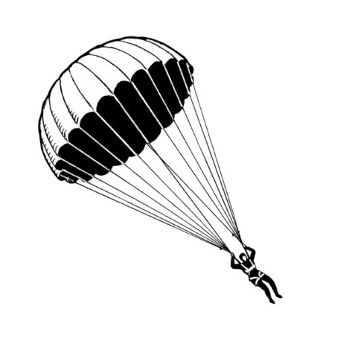



No need to sign up, just show up!

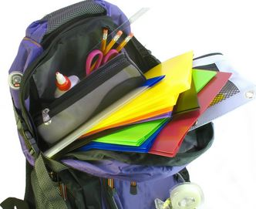
Drop-In Groups



Fall 2015

Stress Management

Feeling overwhelmed? Learn how to cultivate a relationship with stress that allows you to accomplish your goals without leaving you tangled.

Wednesdays

4:45pm—5:30pm

Room 1301
Begins 8/26

1st Year Student Connect

Experiencing some anxiety about your 1st undergraduate year? Learn strategies to cope and effectively navigate your year!

Tuesdays

4:30pm—5:30pm

Room 2438
Begins 9/8

Clues to Help you Snooze

Learn strategies to help improve sleep and self- care to boost focus and overall wellness.

1st Tuesday of every Month

4:45pm—5:30pm

Room 1301

Meditation

Learn to meditate! Join our experienced meditation instructors and learn about this useful practice, offering a calmer perspective and clearer vision.

Thursdays

4:45pm—5:30pm

Room 2438
Begins 8/27

Meditation

Learn to meditate! Join our experienced meditation instructors and learn about this useful practice, offering a calmer perspective and clearer vision.

Thursdays

4:45pm—5:30pm



NC State University Counseling Center Student Health Services Building 919-515-2423 go.ncsu.edu/counseling @NCSUCounseling

